# Exercises: Asynchronous Programming

This document defines the exercises for ["Java Advanced" course @ Software University](https://softuni.bg/trainings/1377/advanced-java-may-2016). Please submit your solutions (source code) of all below described problems in [Judge](https://judge.softuni.bg/).

## Responsive GUI

You are given a project skeleton of a GUI application that looks something like this:

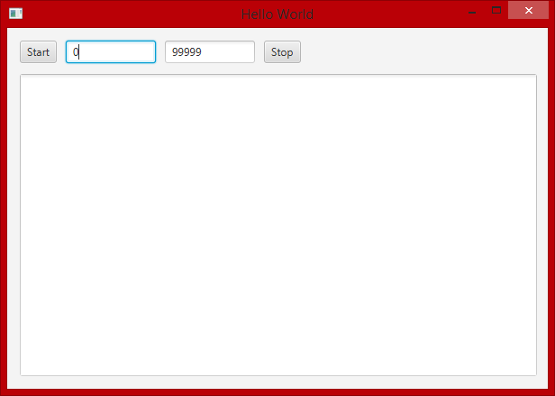

This program finds all prime numbers in the specified range and then prints them in a text field. The problem is that if too big of a range is selected the GUI will freeze while calculating all the primes. Modify the code of the application so that the GUI stays responsive after you press the "Start" button with 0 - 999999 range or more. Also make the "Stop" button stop the calculation of primes and print what's calculated so far.